Mama Mia Purchasing Plan Option 1 Portfolio Project
Justin Turney
MIS 350– Information Systems Analysis and Design
Colorado State University – Global Campus
Dr. Festus Onyegbula
September 10, 2019

Mama Mia Purchasing Plan Option 1 Portfolio Project
Mama Mia is an established and well-known company that produces many different types of pasta products and distributes to grocery stores and food suppliers throughout the United States. The current state of the purchasing system involves the use of an Information System that runs off Microsoft Office. This IS with Microsoft Office comes with a built-in database application. This system is different from the rest of the IS of the company, besides accounts payable, that run off an Oracle database system built off a client-server-server architecture. All servers for the information systems are locally managed with no information being cloud-based due to security concerns. Due to needing to modernize the Information System, the purchasing system will be upgraded to meet current and future needs of improving operations and to increase profits. This will be completed in four phases.
Phase 1: Requirements
Phase one begins with addressing the requirements for the Information System. The new Information System will come with many requirements. These requirements will be created through a Joint Application Design (JAD) session. According to Valachic and George (2017), managers, key users, system analysts and supervisors will work together in an analysis of the current outdated system to make recommendations for what is required in a new IS. After completing an in-depth JAD session, the basic layout for system requirements were determined to be the following:
- Layout
  - A navigation menu should be visible and present whenever the program is being utilized.
  - High quality graphics and background design should be held to minimum to allow for a faster system load time and to save system memory.
  - System “help” prompts should be available in all sections to allow for quick troubleshooting and usage.
- Navigation
  - All areas and sections of the purchasing menu and subpages should be accessible by every end user.
  - Menu selection and corresponding subsections should be displayed
- Main Page
  - Purchase Requisition with ability reject or approve
  - Ability to select Vendors
  - Ability to select purchasing orders and forms
  - Ability to distribute purchase order to vendors
  - Ability to receive purchase orders
The recommended system requirements address the following:
- Vendor management
- Electronically receive/send vendor orders from external sources. Each purchase order will contain a detailed list of items.
- Simplified system accessibility for all end users.
- Purchase requisitions with ability to approve and deny orders.
Feasibility Analysis
The Information System being proposed will utilize an Enterprise Resource Planning (ERP) software. The main idea of the ERP system is to make operations simple and less complex. Using the current MS database has been a waste of company resources. This system has led critical data to be vulnerable to being compromised due to being stored in a single point and this has limited the data sharing and integration with all other departments in the organization. The result of the new IS will be a collection of databases between all departments, most importantly purchasing and accounts payable, that will improve organizational process. The costs of acquiring a new ERP system will depend on many things, one being the number of users required. Costs per user will range from $2,000 to $5,000 per user. Due to all other departments besides accounts payable currently using a functional, streamlined database system, implementation of a new IS will be lower than if it was required to implement a new IS on a larger scale. The estimated total cost for the ERP system is $225,000. This cost is broken down in sections based on expense allocations. The sections included are Database Management, Software, Training/HR and Infrastructure/Hardware. Below is a list that shows total expenses and percentages spent on each of the four sections.
Database Management | $15,750-$24,750 (7%-11%)
Software | $45,000-$56,250 (20%-25%)
Training/HR | $101,250-$123,750 (45%-55%)
Infrastructure/Hardware | $33,750-$45,000 (15%-20%)

As seen from the above chart, most of the money spent will be on training and HR. With the new system, employees will need to train to learn the new IS and become efficient. Initially, employees will need to spend upwards of 15 hours a week learning the new system and being trained by HR.

SCRUM
A SCRUM team will be the focus of this project. The team will have the development team, product owner and the scrum master. According to Struele et al. (2016), all major decisions will be made with the SCRUM team and will be based off all required credentials and proficiencies. Roles of the SCRUM team are as follows:
- Product Owner: Responsible for defining the work and prioritizing the tasks (Landau, 2018). The product owner is constantly working towards aligning the work with project objectives. Develop a product backlog to ensure that all deliverables are completed on time.
- SCRUM Master: Responsible for ensuring distractions do not de-rail the project and keep the project on track based on the scrum process. The scrum master is accountable for the scrum process and for ensuring all members work together.
- Development Team: Responsible for the work of the project. Every team member has a skill set the is needed in the development of the project. Work together will all members of the team from start to finish. The development team is responsible for addressing and submitting project deliverables in a timely manner.
All SCRUM events are set by the scrum master. This includes initialization activities that will start with a meeting to address all details of the project and requirements of the client. The product owner will provide a product backlog. The development team will begin their work on deliverables during the sprint planning. In the sprint planning, a fixed time period is set for when the development team will aim to achieve the state of “done” with the project (Enterprise Project Management, 2018). The mentioned state of “done” is when the proposed deliverables for the project will be delivered.

SCRUM Deliverables
- SCRUM team members and stake holders’ names
- Product backlog with list of user requirements from product owner listed by priority
- Spring backlog that the team will work on during the “sprint” to include activities, tasks, and project status.
- A burn chart that will be a graphic representation of completed or incomplete tasks. The scrum master will maintain the burn chart.
- Budget that will be tracked to ensure project costs are within allocated funds
Phase 2: Data Flow Analysis
With the completion of Phase 1, we move forward with Phase 2 which involves creating and analyzing Data Flow Diagrams (DFD). The DFD is a simple diagram that is used to show the flow of data and processes needed for a system to operate properly. Without a proper flow of data, Mama Mia would not be able to receive customer orders, route the order, and ensure that the correct vender is chosen and that the accounts payable branch is able to send out invoices for services provided. The purchasing department relies on the correct flow of data to complete a customer order and choose the correct vender and product to ensure that orders are completed and processed in a timely manner. Failure to do this due to improper data flow and incorrect diagrams created in the planning process would lead to delays of orders being completed, unhappy customers, and increased expenses to fix the issues and potentially lose customers. According to Darrington (n.d.), the most important aspect of a data flow diagram is that it keeps the information system organized and shows where the processes need to go to. Once the layout of the system is drawn out and can be visualized, decisions can be made of how to design the IS. The provided diagrams show the information flow of the purchasing department for Mama Mia.
Context/Level 0
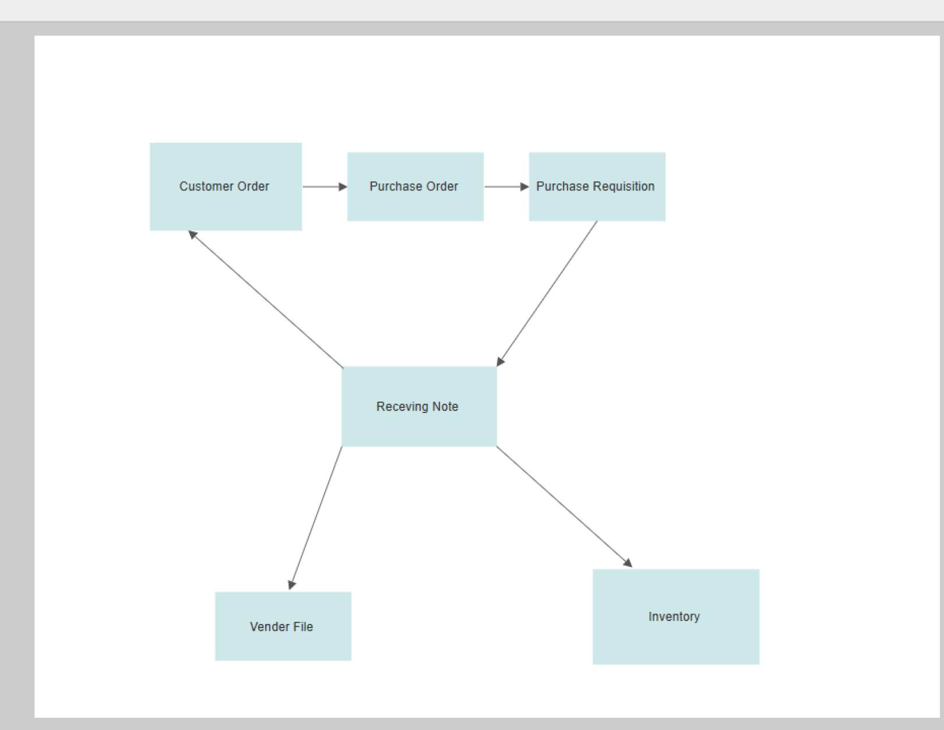
Level 1 Purchase Data Flow

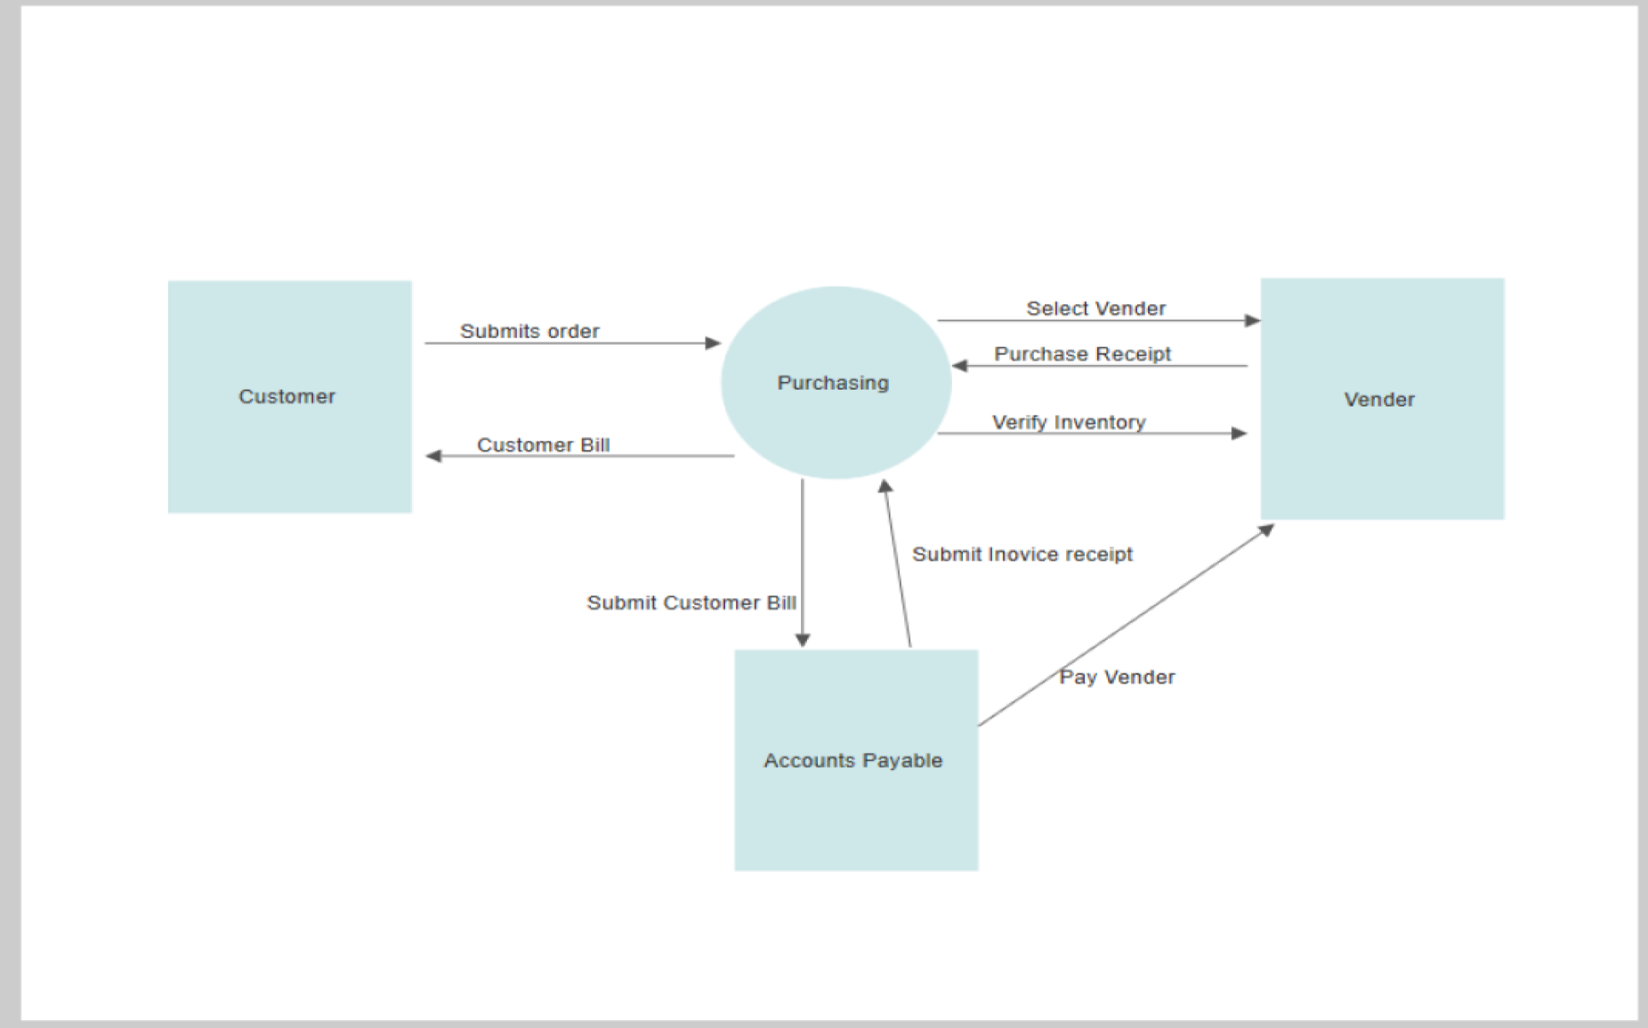

Phase 3: Entity-Relationship Model and Design
With the completion of the second phase, we now move forward with Phase 3 which is taking the DFD and transforming it into an Entity-Relationship Model (ERD) and the breakdown of it to make a physical database. The Information System must be filled with meaningful data that is relevant to the Purchasing Department. The following ERD shows what the database will include and the information that will be implemented into the database.
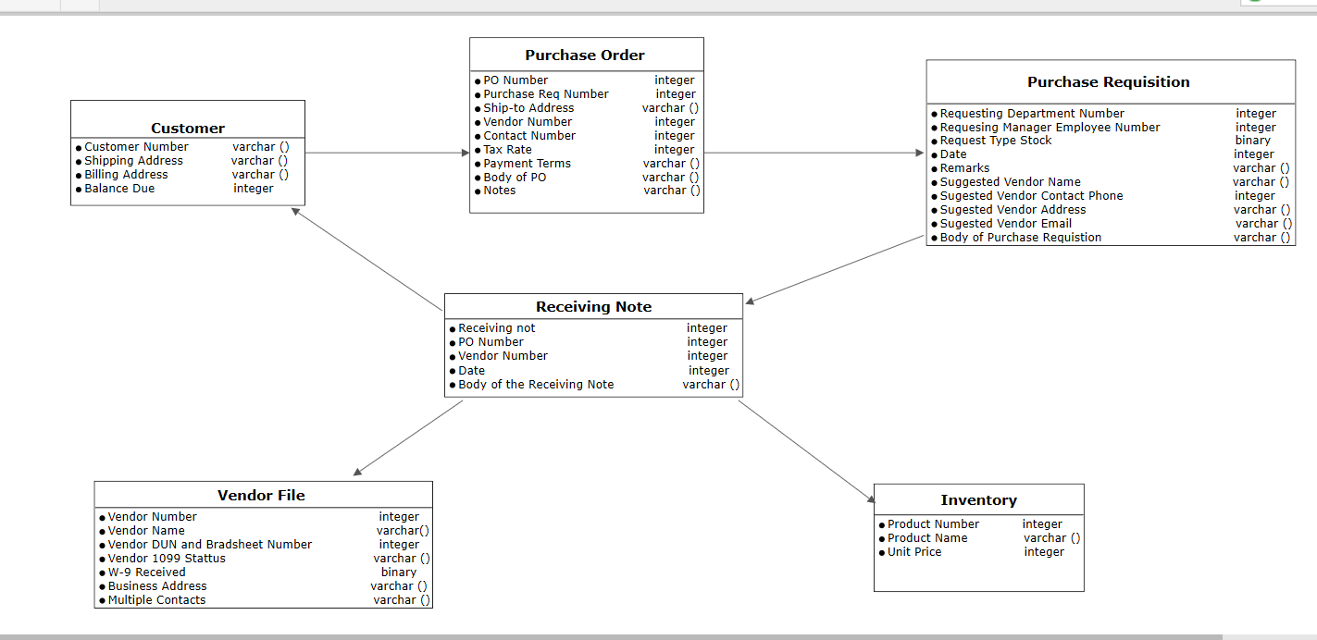
The following is a breakdown a flow of data between all entities:
- Customer
  - Name (primary key)
  - Customer Number (varchar)
  - Shipping Address (varchar)
  - Billing Address (varchar)
  - Balance Due (integer)
- Purchase Order
  - PO Number (primary key)
  - Purchase Req Number (integer)
  - Ship-to-Address (varchar)
  - Vendor Number (integer)
  - Contact Number (integer)
  - Tax Rate (integer)
  - Payment Terms (varchar)
  - Body of PO (varchar)
  - Notes (varchar)
- Purchase Requisition
  - Requesting Department Number (integer)
  - Requesting Manager Employee Number (integer)
  - Request Type Stock (binary)
  - Date (integer)
  - Remarks (varchar)
  - Suggested Vendor Name (varchar)
  - Suggested Vendor Contact Phone (integer)
  - Suggested Vendor Address (varchar)
  - Suggested Vendor Email (varchar)
  - Body of Purchase Requisition (varchar)
- Receiving Note
  - Receiving Note (integer)
  - PO Number (integer)
  - Vendor Number (integer)
  - Date (integer)
  - Body of the Receiving Note (varchar)
- Inventory
  - Product Number (integer)
  - Product Name (varchar)
  - Unit Price (integer)
- Vendor File
  - Vendor Number (integer)
  - Vendor Name (varchar)
  - Vendor DUN and Bradsheet Number (integer)
  - Vendor 1099 Status (varchar)
  - W-9 Received (binary)
  - Business Address (varchar)
  - Multiple Contacts (varchar)
The design of the database includes six entities that are made of attributes and identifiers. Entity number one is named Customer. The Primary Key is Name, with an assigned data type of varchar. Dependent upon the values it can take, the data type that is populated in the information system. In the case of this data type varchar, which is a variable character, a set of data characters of an unknown length is populated. Balance due would be assigned a data type of Integer because these values in the data type are numeric. Once the customer places a purchase order in this system, the information flows to another entity called Purchase Order with the attribute PO Number. PO Number is the primary key and is an integer for its data type. Additional attributes include shipping address (varchar), purchase requisition (integer), payment terms (varchar), and tax rate (integer). From here the data will flow to another entity called Purchase Requisition, then to the entity Receiving Note. This will branch off and flow to both entities Vender File and Inventory. Finally, the entity Receiving Note will go back to the entity Customer and the flow of data for the Purchase Department will be complete. When analyzing the ERD, it is easy to see how the flow of data moves between numerous entities. Some keys are assigned foreign keys so that cross-referencing searches can occur. This will lead to easier database queries.
Phase 4: Implementation
The fourth and final phase of the project is the Implementation Phase. The Implementation Phase includes the testing, training, implementation strategy and DevOps. According to Valachic and George (2018), systems implementation is completed to take the specifications of the system into reliable and working software and hardware, documenting the work and providing support for both current and future end users.
Test Plan
The testing plan is vital to the success of the project and IS. Software testing needs to begin early during the implementation phase. Software testing will also be completed in the analysis phase where a master test plan will be developed and implemented. This master test plan will be used to run and track multiple tests from different phases of the project and will be used to put a “check in the box” and determine when we have completed the test plan. Module testing will also be performed. According to Valachic and George (2018), module testing acts as an automated technique where each module is independently tested from the others to find errors. This will be done along with integration testing because modules exist together in a system and must be tested together with all other parts of the system (Valachic and George, 2018). Programs will be integrated with each other during system testing so that we can determine if the IS will work without error and that all programs are compatible with each other. Valachic and George (2018) state that the testing process must be structured and make sense logically; attention to detail must be implemented. This is to ensure that boundary data, response time, missing inputs, and heavier than normal input can be sustained and satisfy all system requirements. The heaviest trafficked areas of the system must receive the most testing to ensure that these systems are error free and users will not experience any type of system failure or slow down. Once all system tests are completed according to the master test plan, the system must be tested in the environment it will be used in, this is known as acceptance testing. The end users will need to test and use this system and determine if it meets their needs or if further development and testing is required. If the user’s needs have been meant, the system will be accepted.
Training Plan
As with any new system, proper training will be the key to the success and implementation of the new system. As with any other system, end users will need to understand the hardware, software, and constraints that are available and utilized with the new system. The following list includes all steps of the training plan that users will need to learn and familiarize themselves with:
- Accessing the system (how to enter the program)
- User requirements and rules of the system (what is allowed and what is not)
- Using the system (how to retrieve a purchase order)
- Query the system (how to execute a query to find data)
- Refresh on basic computer and program skills
- IS concepts (batch file processing)
- System Management (how to make changes to system)
- Maintenance (backup, update, submit trouble tickets)
- Utilizing the Help Menu (how to navigate system help menu for common problems)
The beginning stages of training will be done in person for ten hours per week and will involve a team of system experts to explain and teach how the system works. This will be the costliest aspect of the training, but studies have shown this to be the most effective way to introduce a new IS to users. Following this initial training, employees will be required to access and complete an online or e-learning program to become efficient with the program and ensure implementation goes with few issues. According to Valachic and George (2018), and e-learning program can be completed online and will provide users with simulated labs so they ae able to work with the new system and introduce them to possible scenarios of problems that can occur and train them to correct these issues. The great thing about the online e-learning is that it can be completed from anywhere that web access is available and will allow the employees to train and become proficient in the system in a low-stress environment. With all the available training, there is still the possibility of employees not understanding how to work with the system and the solution to this will be the online forums and support vendors who can help them solve any problem that may arise. Finally, third-party vendors and automated support will be available to release updates, report bugs, errors in the system, and release corrective patches to ensure the system is always running at 100% and users are not experiencing any issues.
DevOps
DevOps is the combination of cultural philosophies, practices and tools that increases an organization to deliver application and services at a high velocity (Amazon Web Services, 2019). This is a very popular methodology in project development. DevOps allows a culture to be built that includes collaboration, shared responsibility, and fast feedback. DevOps will help an organization prosper and will allow ensure that the people who write codes, build the information system and manage it are responsible for maintaining the IS. Mueller (2010), stated that if you build it, you own it, when referencing the implementation and of a new IS and managing the system one it is up and running. DevOps will ensure that continuous deployment and integration of the system will occur. This will be maintained by developers being available at anytime and having remote access when needed to monitor the system and maintain the systems that they designed. This allows a higher level of collaboration between the developers and IS operating during the systems life cycle. Mama Mia will benefit greatly from this due to not having to worry about losing support for all systems at any time. Mama Mia will not only be able to compete with competitors in the industry, but they will be able to lead all others due to developers and operators working together to maintain this advanced system. DevOps will reduce the implementation time and deployment failures due to shorter development cycles. Finally, business continuity will be increased by DevOps. According to Stair and Reynolds (2018), a disaster recovery plan will be put in place with DevOps participating in the recovery process for the organizations Information Systems assets. This includes everything from hardware and software, to data and networks. DevOps is a great thing for the implementation of the new IS for the purchasing department and Mama Mia as a whole. In the long run, costs will be reduced drastically, and profit will increase faster than ever before. According to Lambert (2019), a much more stable product implementation is enacted, and the amount of time implementing and maintain the system will be reduced. This will lead to long term cost reduction and profit increases. With all of this stated on DevOps, it would be a mistake to not utilize this with the IS implementation and in the culture of Mama Mia.

References
Amazon Web Services. (2019). What is DevOps. Retrieved from https://aws.amazon.com/devops/what-is-devops/
Darrington, J. (n.d). Importance of Data Flow Diagrams. Retrieved from https://www.techwalla.com/articles/importance-of-data-flow-diagrams
Enterprise Project management Office. (2018). Scrum Minimum deliverables. Vermont
Government Website. Retrieved from https://epmo.vermont.gov/scrum_minimum_deliverables
Lambert, B. (2019). How DevOps can Reduce Operational Costs. Retrieved from https://cloudacademy.com/course/introduction-to-devops/how-devops-can-reduce-operational-costs-1/
Landau, P. (2018). SCRUM Roles: The Anatomy of a SCRUM Team. Retrieved from https://www.projectmanager.com/blog/scrum-roles-the-anatomy-of-a-scrum-team
Mueller, E. (2010). The Agile Mind. What is DevOps?. Retrieved from
https://theagileadmin.com/what-is-devops/
Streule, Miserini, Bartlomé, Klippel, & De Soto. (2016). Implementation of Scrum in the
Construction Industry. Procedia Engineering, 164, 269-276.
Valachic, J. S., & George, J. F. (2018). Modern Systems Analysis and Design (8th ed.). New York, NY: Pearson.

